
STUDENT: MICHAEL ASILWA
ADMISSION: BSCCS/2024/56330
COURSE: COMPUTER SCIENCE
UNIT CODE: BIT4138
UNIT NAME: ADVANCED CRYPTOGRAPHY
LECTURER NAME: Michael Nyoro
ACADEMIC YEAR: Year 3 semester 2
PROJECT DETAILS
PROJECT TITLE: SECURE FILE ENCRYPTION AND MESSAGING SYSTEM
SELECTED TECHNOLOGIES:
Python + cryptography libraries
OpenSSL + Linux
GITHUB REPOSITORY LINK: https://github.com/xxplosi/Advanced-cryptography

Contents
WEEK ONE: CRYPTOGRAPHY ENVIRONMENT SETUP 4
Title: installation and configuration of cryptography development environment 4
FIG 1: python and vs code installation 5
FIG 2: cryptography libraries installed 5
FIG 3: OpenSSL installation Test 6
FIG 4: local encryption script 6
FIG 5: GitHub repository initialization 6
STUDENTS REFLECTION 6
WEEK 2: CLASSICAL CRYPTOGRAPHY AND CIPHER DESIGN 7
Title: implementation of classical encryption algorithm’s 7
FIG 1: Caesar cipher implementation 7
FIG 2: Vigenère cipher encryption process 7
FIG 3: encryption and decryption output 8
FIG 4: user input validation interface 8
FIG 5: cipher testing results 9
STUDENTS REFLECTION 9
WEEK 3: STREAM CIPHERS AND RANDOMNESS TESTING 10
Tittle: implementation of stream cipher systems and random sequence analysis 10
FIG 1: LFSR generator implementation 10
FIG 2: pseudorandom sequence output 10
FIG 3: statistical randomness testing 11
FIG 4: RC4 stream cipher simulation 11
FIG 5: Encryption performance results 12
STUDENTS REFLECTION 12
WEEK 4: BLOCK CIPHER DESIGN AND AES 13
Title: AES and block cipher operations 13
FIG 1: AES encryption 13
FIG 3: file encryption demonstration 14
FIG 4: Decryption results 14
FIG 5: performance testing 15
STUDENTS REFLECTION 15
WEEK 5: PUBLIC KEY CRYPTOGRAPHY 15
Title: implementation of RSA encryption and key management 15
FIG 1: RSA key pair generation 16
FIG 2: public key encryption process 16
FIG 3: private key decryption results 16
FIG 4: secure message transmission 17
FIG 5: RSA testing and validation 17
STUDENTS REFLECTION 17
CREATIVE TASK 18
FIG 6 : RESULTS OUTPUT 18
Week 6: SYMETRIC CIPHERS 2 19
Title: substitution-permutation networks, s-boxes and non-linearity 19
19
FIG 1: SPN basics output 19
FIG 2: SPN advanced output 19
FIG 3: mini AES output 20
WEEK 7: BLOCK CIPHER CRYPTANALYSIS 20
Title: Differential cryptanalysis and Linear cryptanalysis 20
FIG 1: differential cryptanalysis output 20
FIG 2: output showing frequency analysis, statistical bias and output difference 21
FIG 3: difference analysis output 21
FIG 4: Avalanche test results output 22
FIG 5: full statistical report output 22
STUDENTS REFLECTION 22

WEEK ONE: CRYPTOGRAPHY ENVIRONMENT SETUP

Title: installation and configuration of cryptography development environment
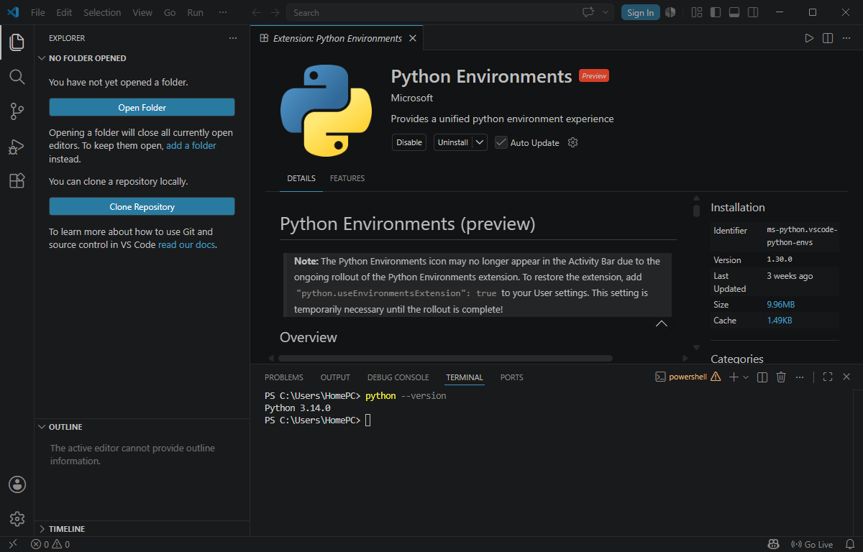

FIG 1: python and vs code installation
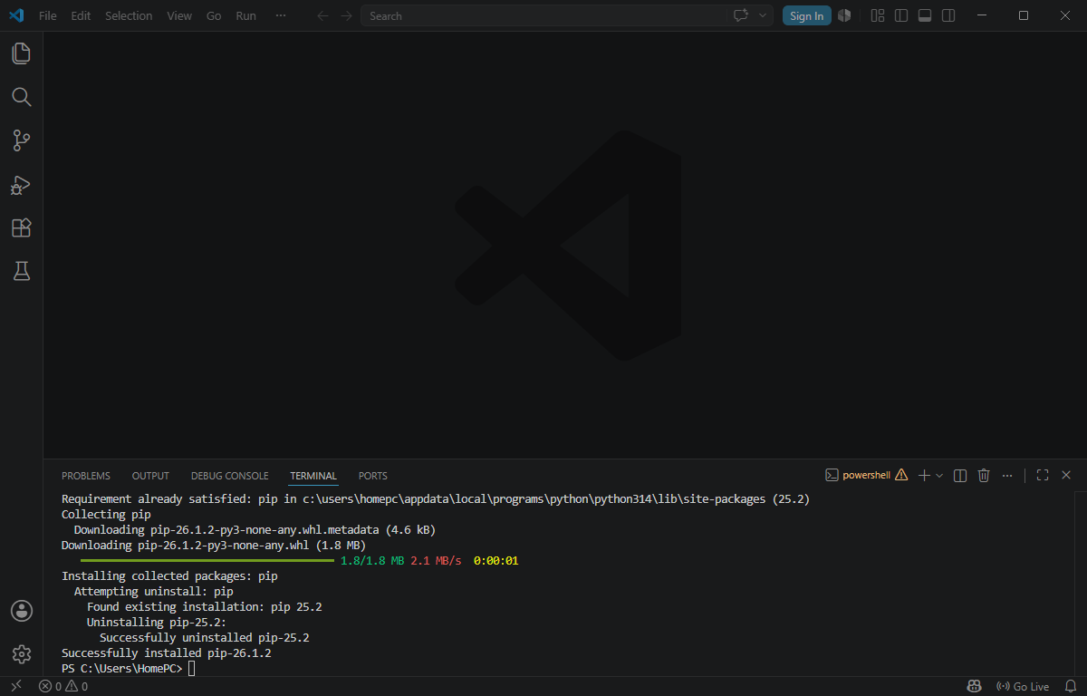

FIG 2: cryptography libraries installed

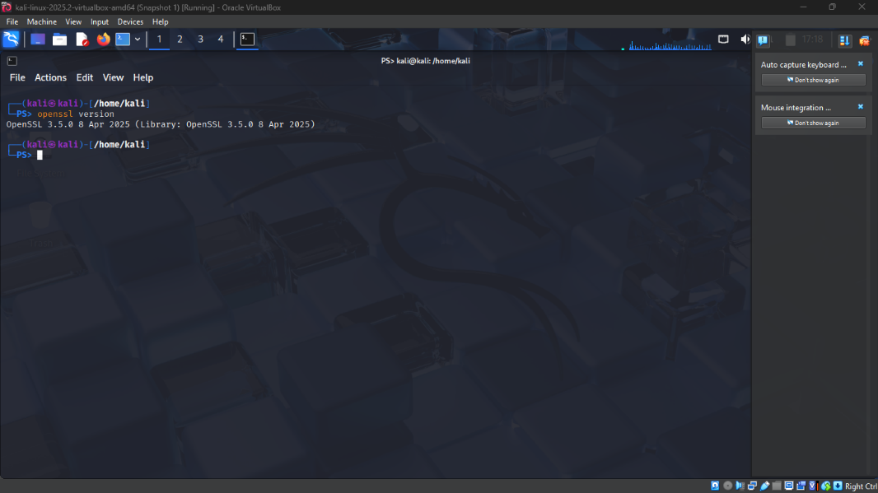

FIG 3: OpenSSL installation Test
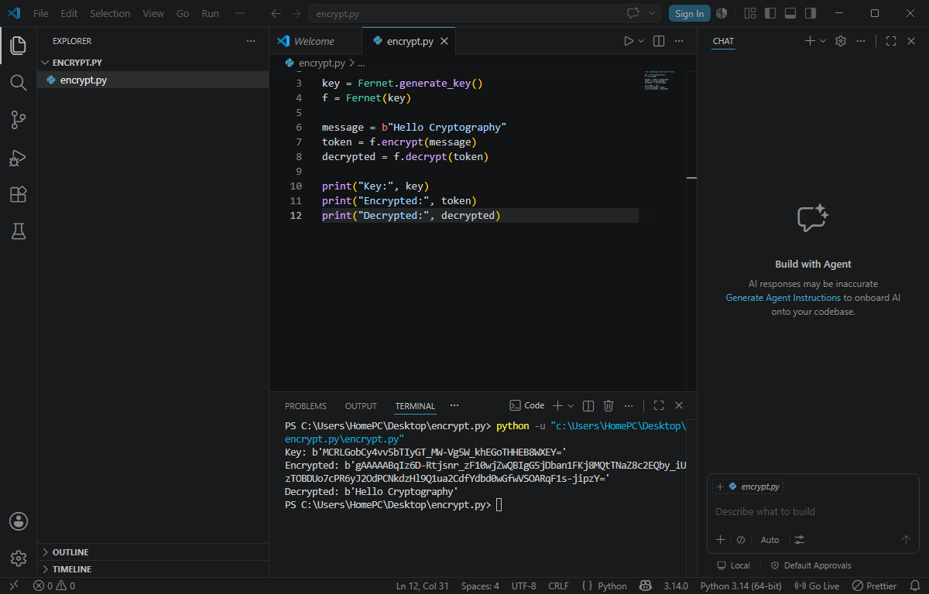

FIG 4: local encryption script

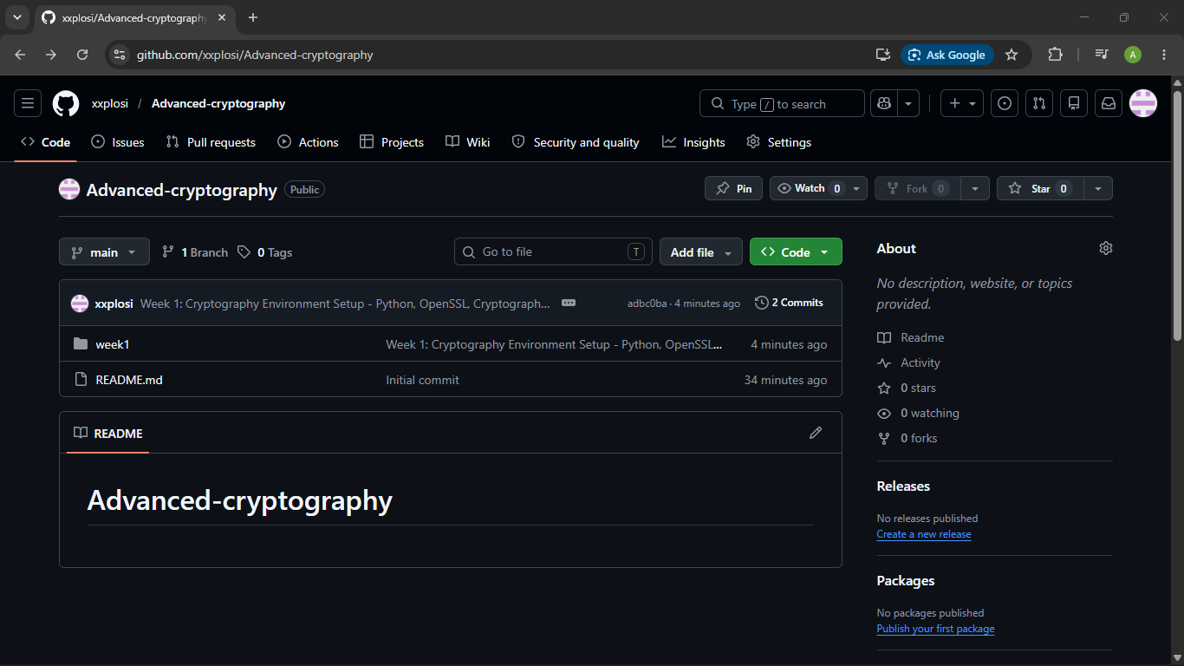

FIG 5: GitHub repository initialization

STUDENTS REFLECTION
During this task I understood initializing a GitHub repository together with the installation of cryptography libraries. I did not encounter any challenges as the installation was easy

WEEK 2: CLASSICAL CRYPTOGRAPHY AND CIPHER DESIGN

Title: implementation of classical encryption algorithm’s
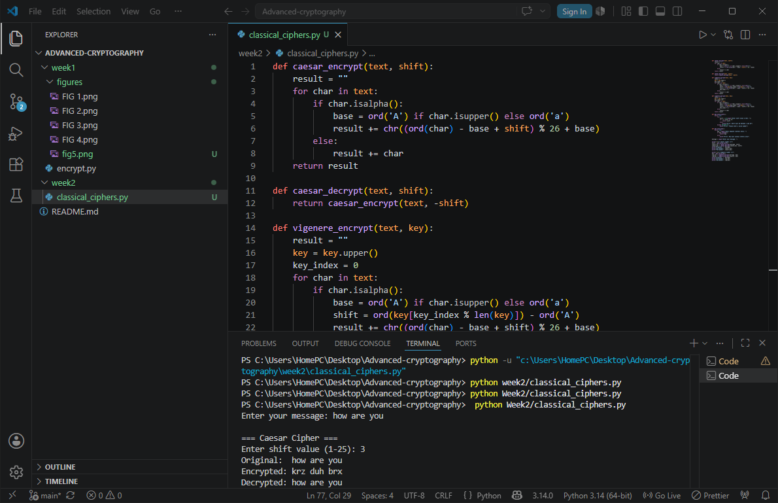

FIG 1: Caesar cipher implementation
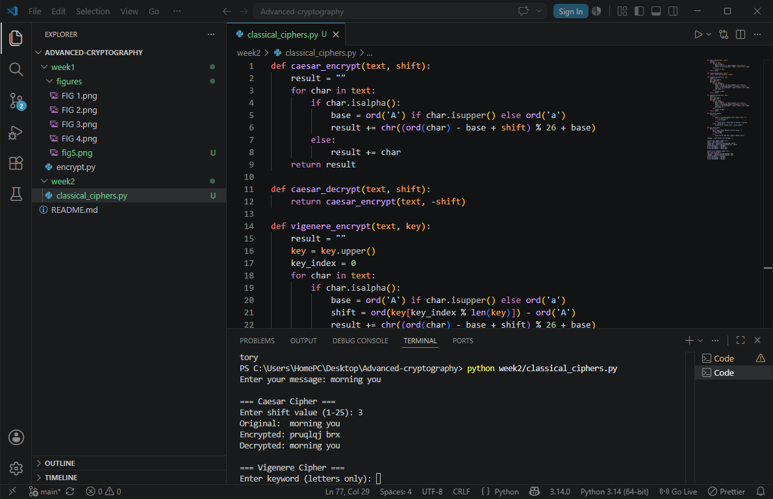

FIG 2: Vigenère cipher encryption process

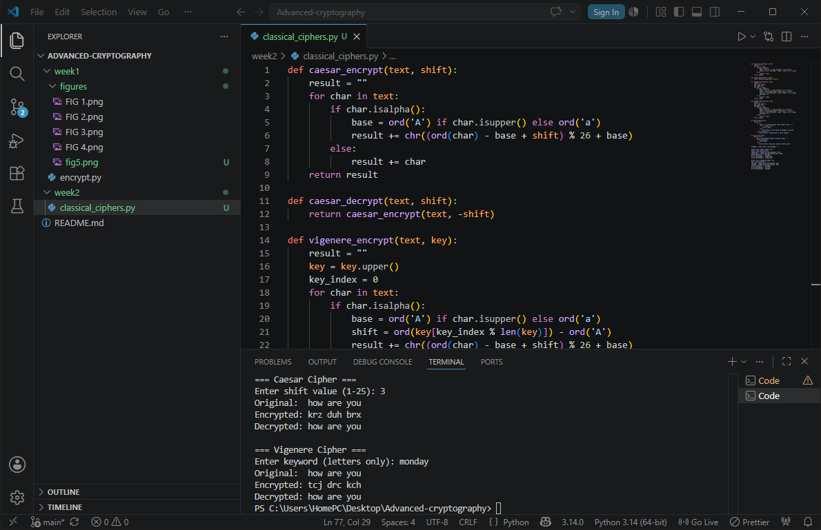

FIG 3: encryption and decryption output

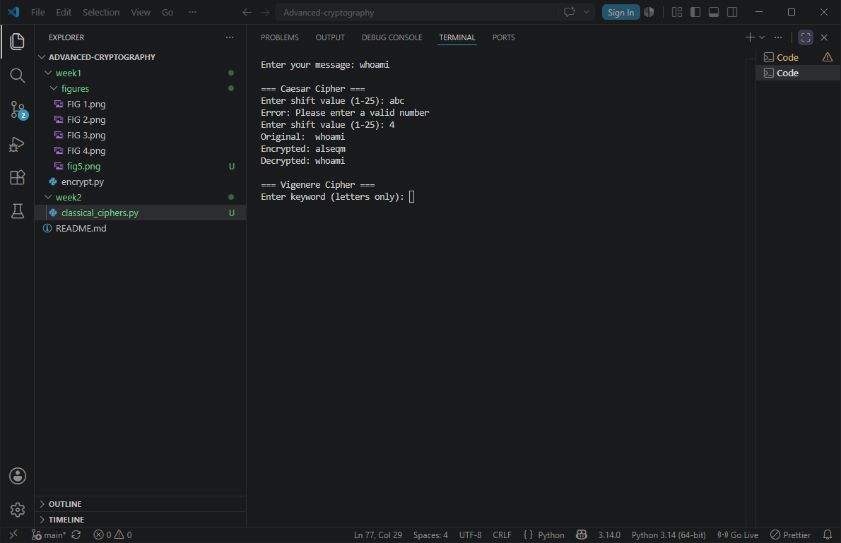

FIG 4: user input validation interface

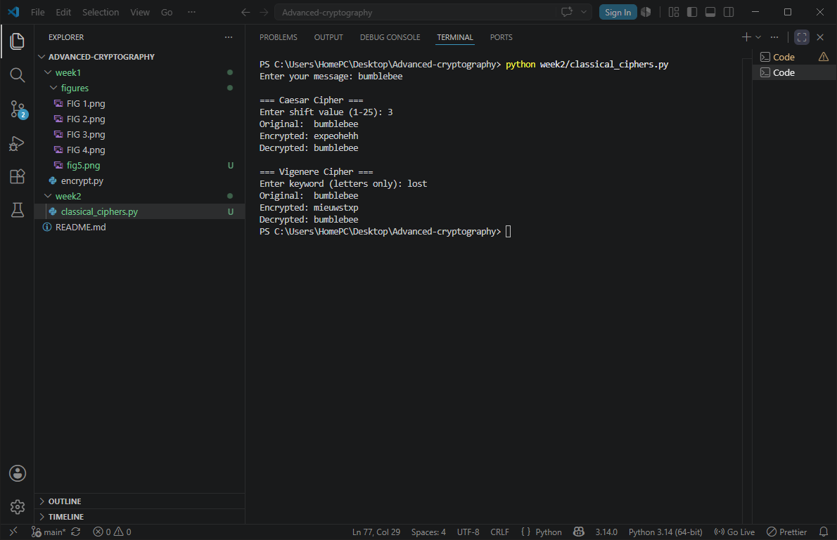

FIG 5: cipher testing results

STUDENTS REFLECTION
Caesar shifts each letter by a fixed number, Vigenère shifts each letter by a different amount based on a keyword. Encryption workflow: plaintext → key → ciphertext → reverse → plaintext back.
Caesar is weaker than Vigenère since it only has 25 possible shifts

WEEK 3: STREAM CIPHERS AND RANDOMNESS TESTING

Tittle: implementation of stream cipher systems and random sequence analysis
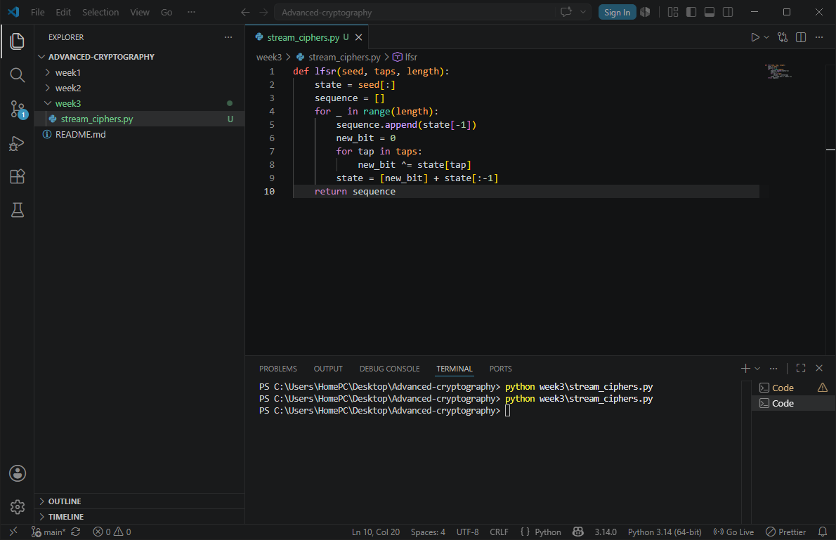

FIG 1: LFSR generator implementation
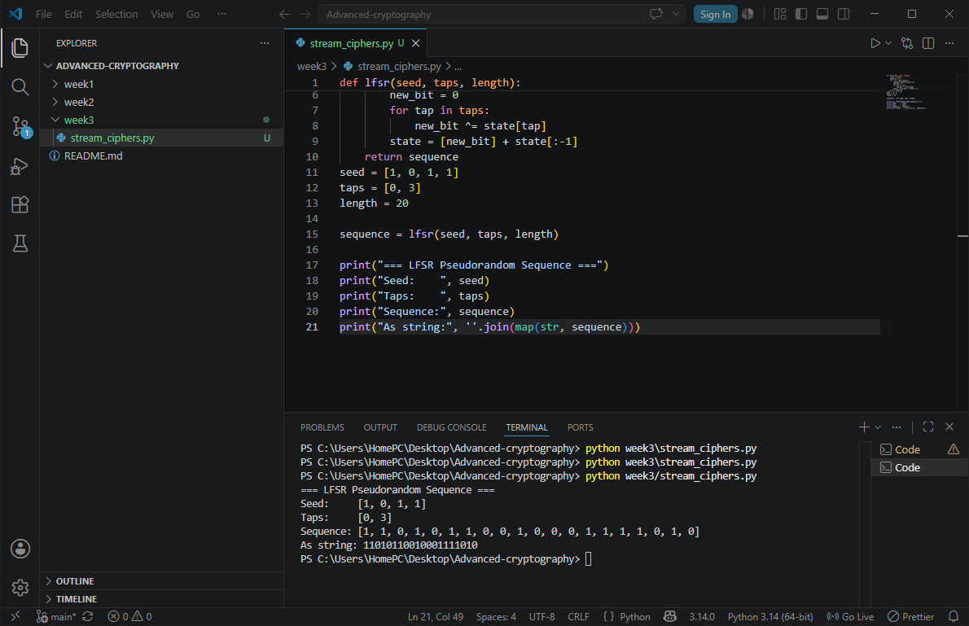

FIG 2: pseudorandom sequence output

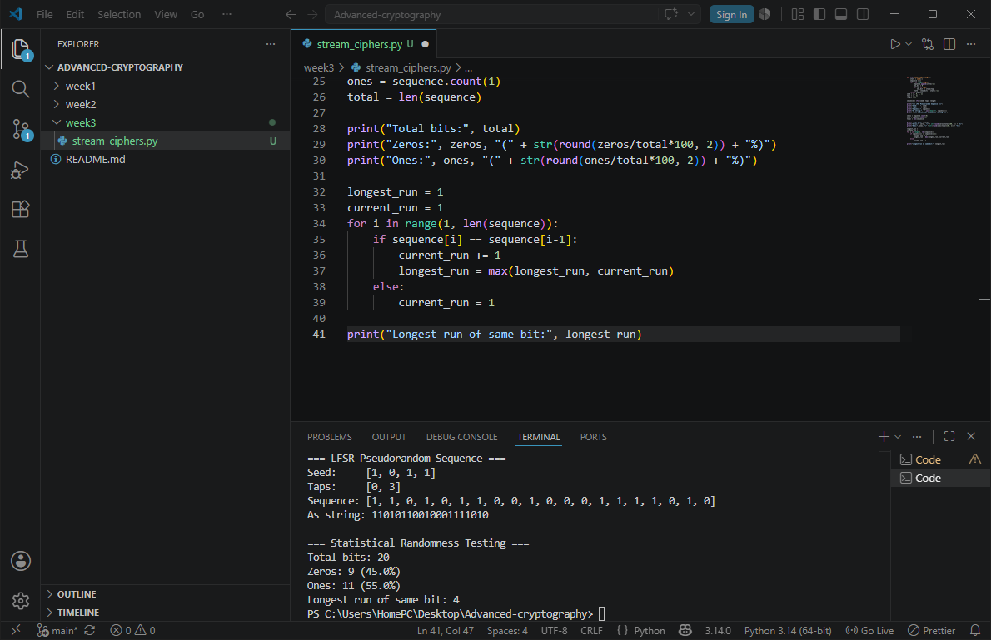

FIG 3: statistical randomness testing
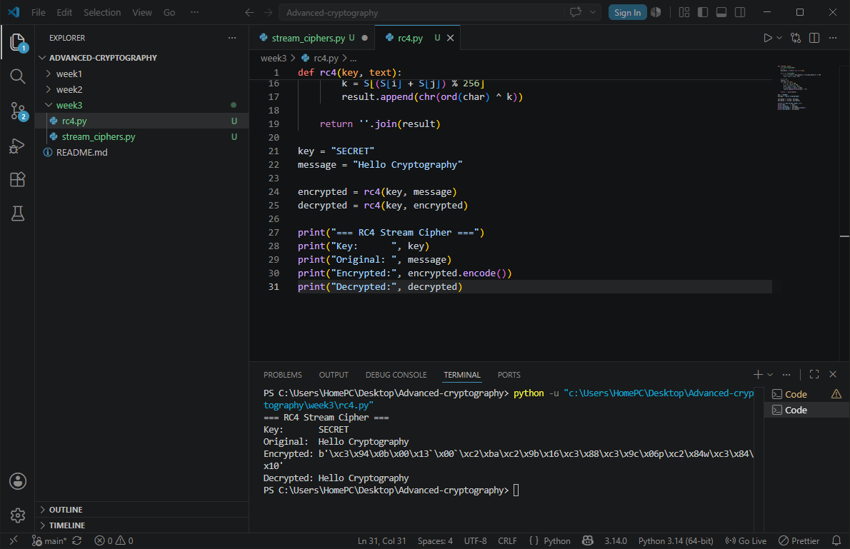

FIG 4: RC4 stream cipher simulation

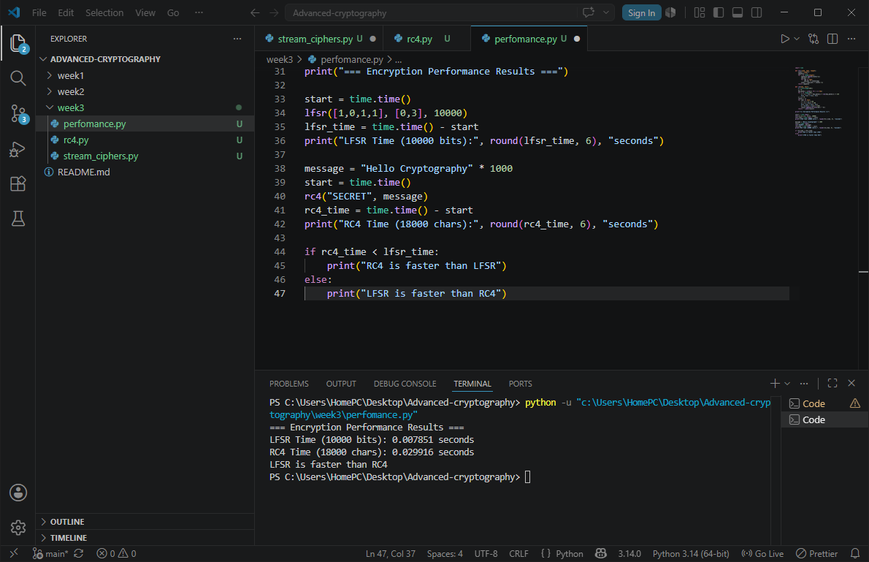

FIG 5: Encryption performance results

STUDENTS REFLECTION
I learnt how stream ciphers encrypt data one bit at a time using pseudorandom keystreams
LFSR generates pseudorandom bits using XOR and nit shifting from a seed value
Short seeds and repeated keystreams are some of the weaknesses in security.

WEEK 4: BLOCK CIPHER DESIGN AND AES

Title: AES and block cipher operations
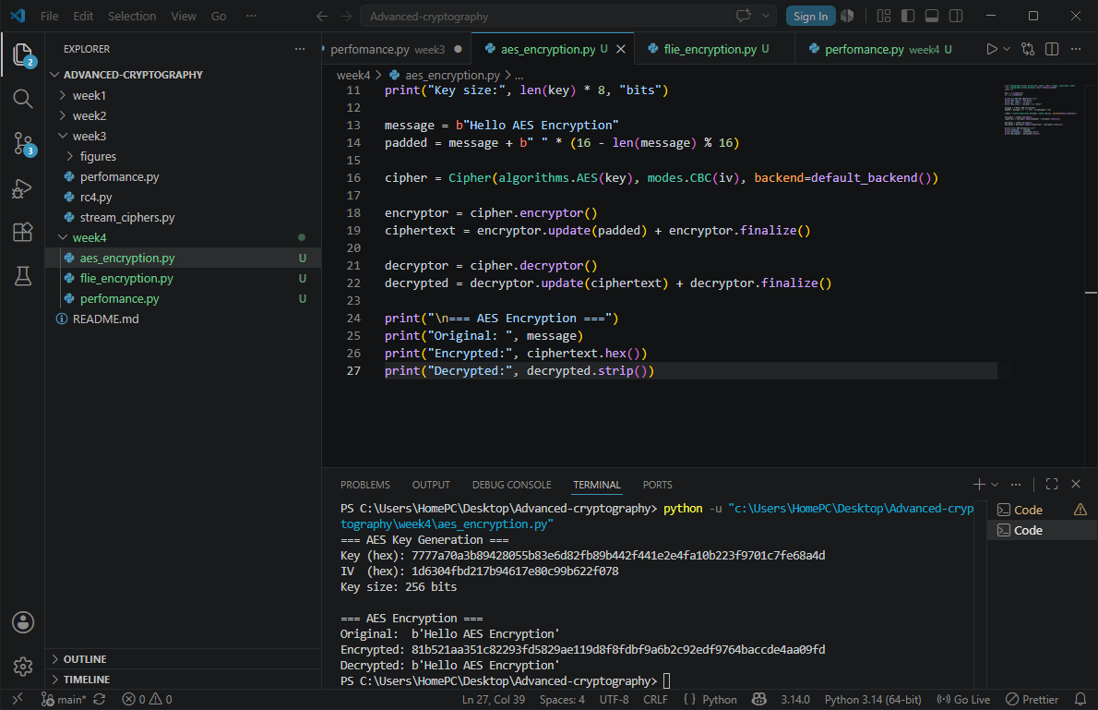

FIG 1: AES encryption

FIG 2: key generation process

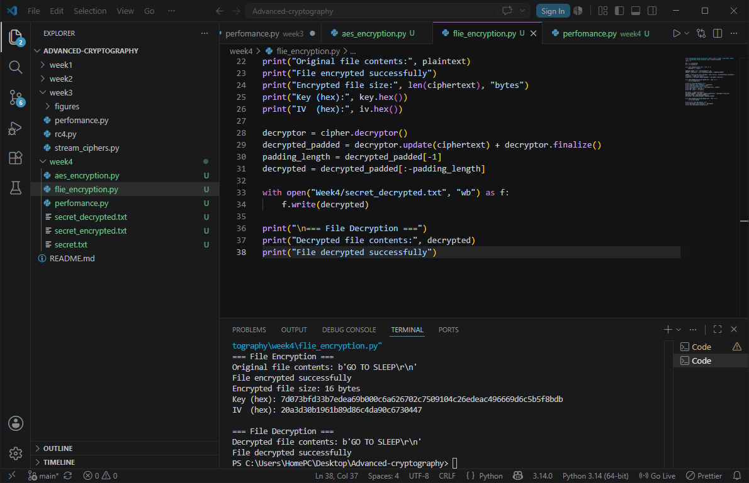

FIG 3: file encryption demonstration


FIG 4: Decryption results

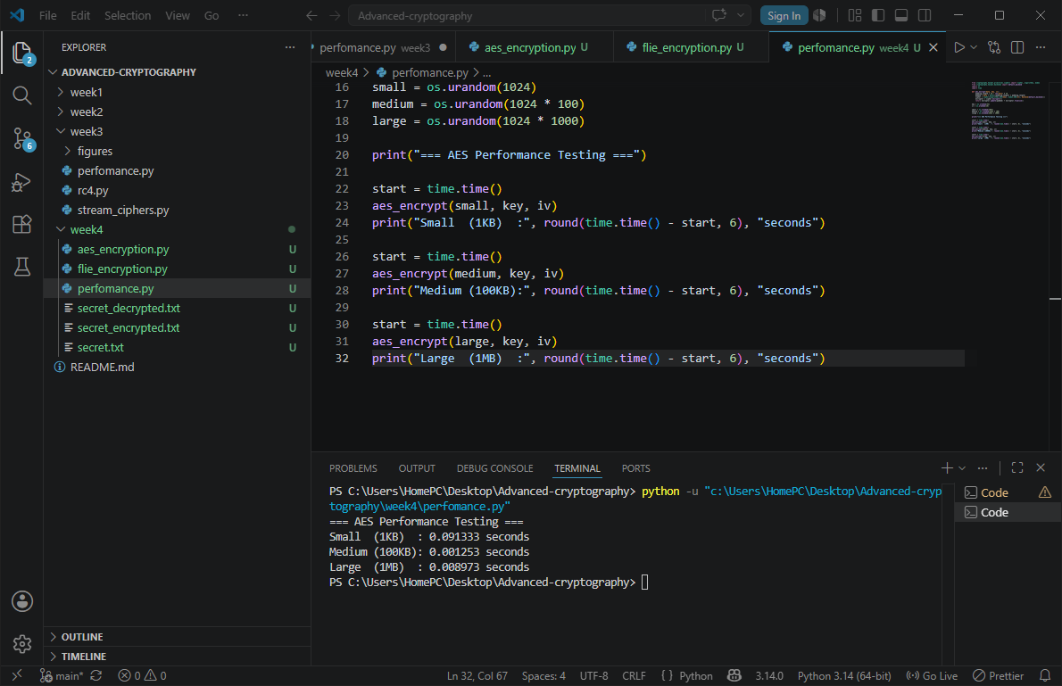

FIG 5: performance testing

STUDENTS REFLECTION
Learnt that AES encrypts data in 128-bit blocks using multiple rounds of substitution,
Sifting and XOR operations. Challenge encountered was handling the padding to meet AES block size requirements.

WEEK 5: PUBLIC KEY CRYPTOGRAPHY

Title: implementation of RSA encryption and key management
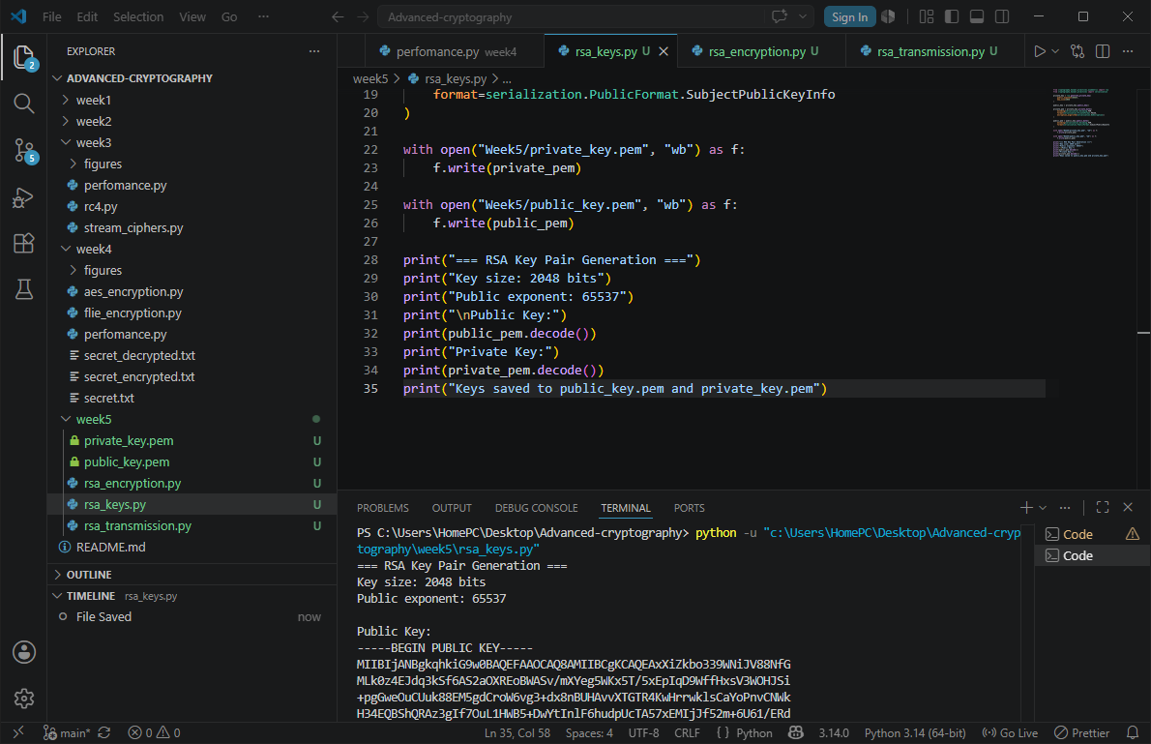

FIG 1: RSA key pair generation
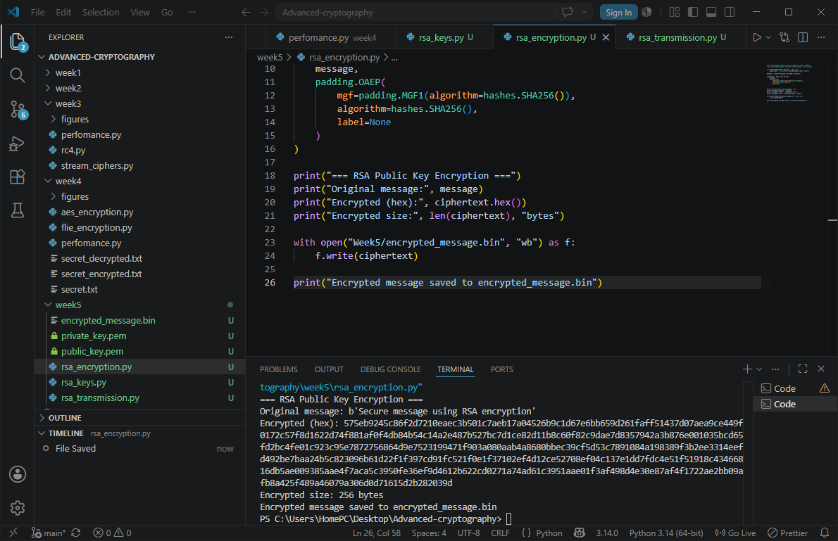

FIG 2: public key encryption process
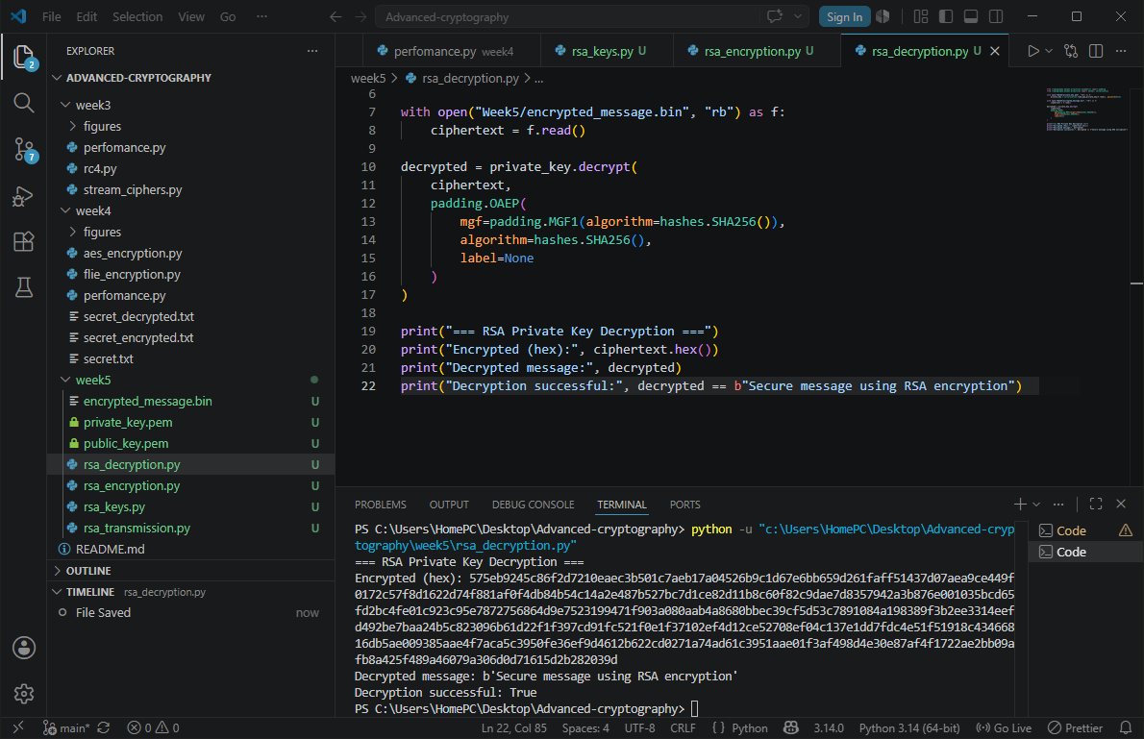

FIG 3: private key decryption results

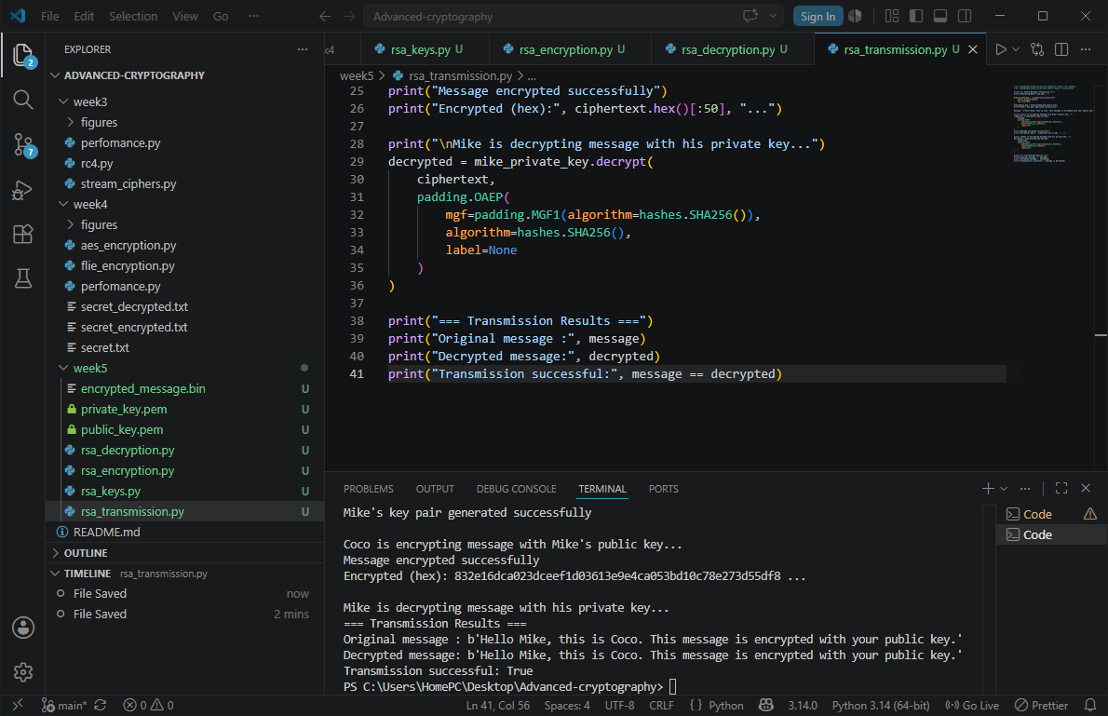

FIG 4: secure message transmission
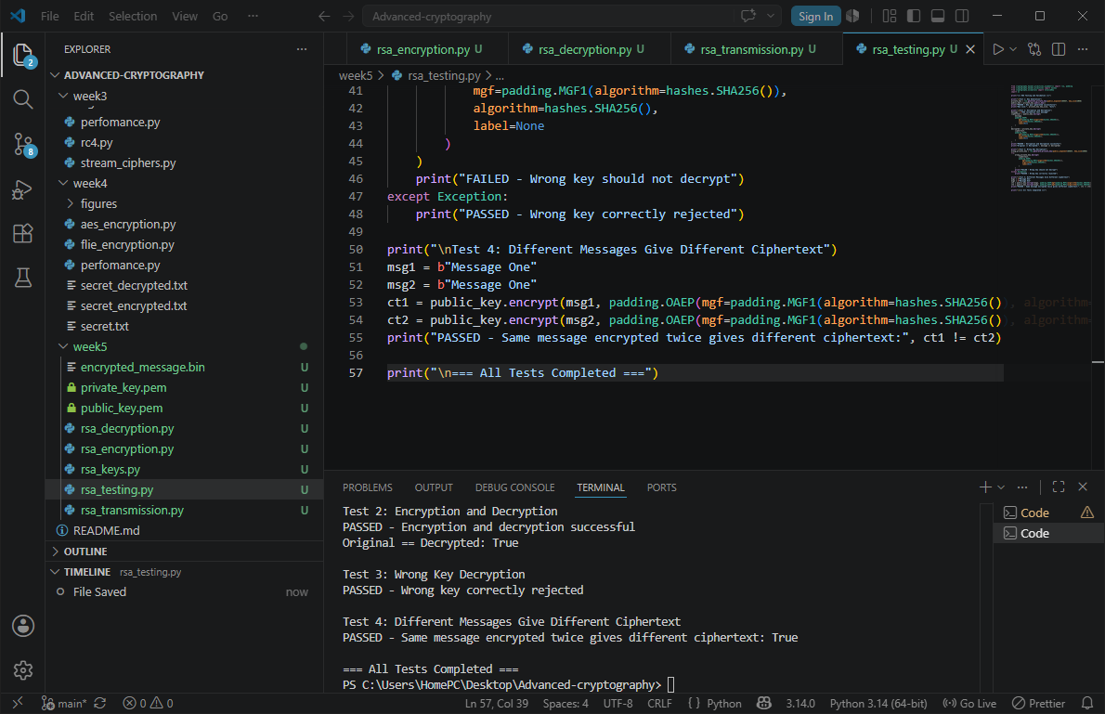

FIG 5: RSA testing and validation

STUDENTS REFLECTION
RSA uses public and private key for encryption and decryption unlike symmetric which uses one for both.
The public key is shared openly while the private key stays secretly

CREATIVE TASK
A secure chat simulator where a user can choose an encryption method ,type a message and see it encrypted and decrypted
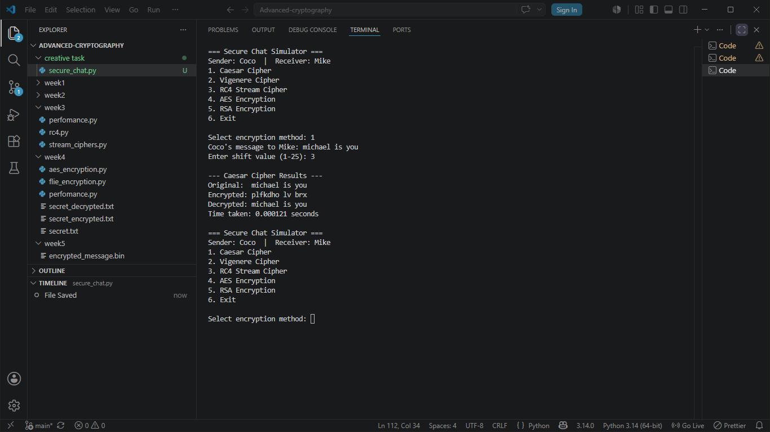

FIG 6 : RESULTS OUTPUT

Week 6: SYMETRIC CIPHERS 2

Title: substitution-permutation networks, s-boxes and non-linearity

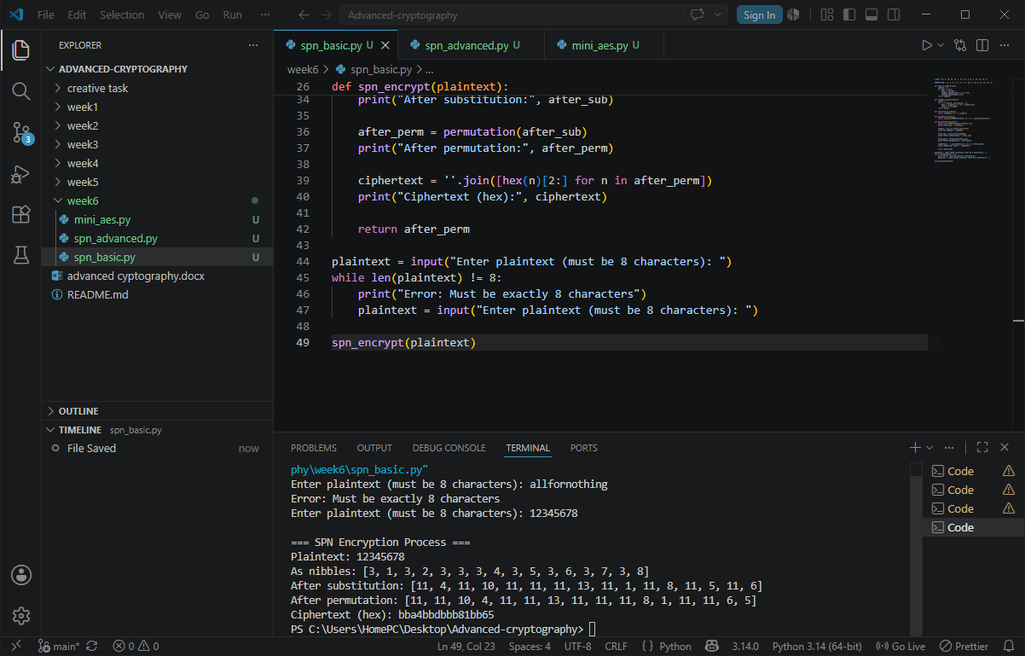

FIG 1: SPN basics output
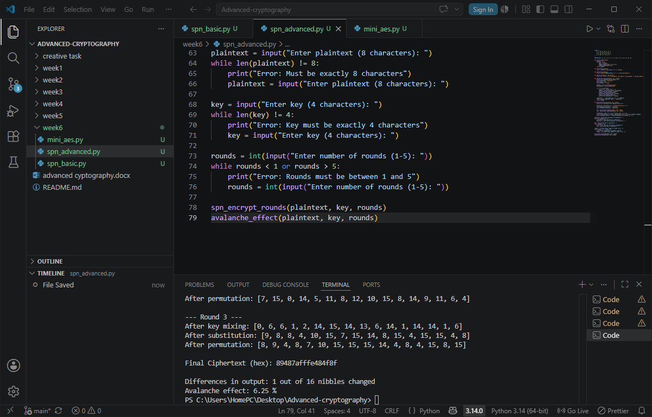

FIG 2: SPN advanced output

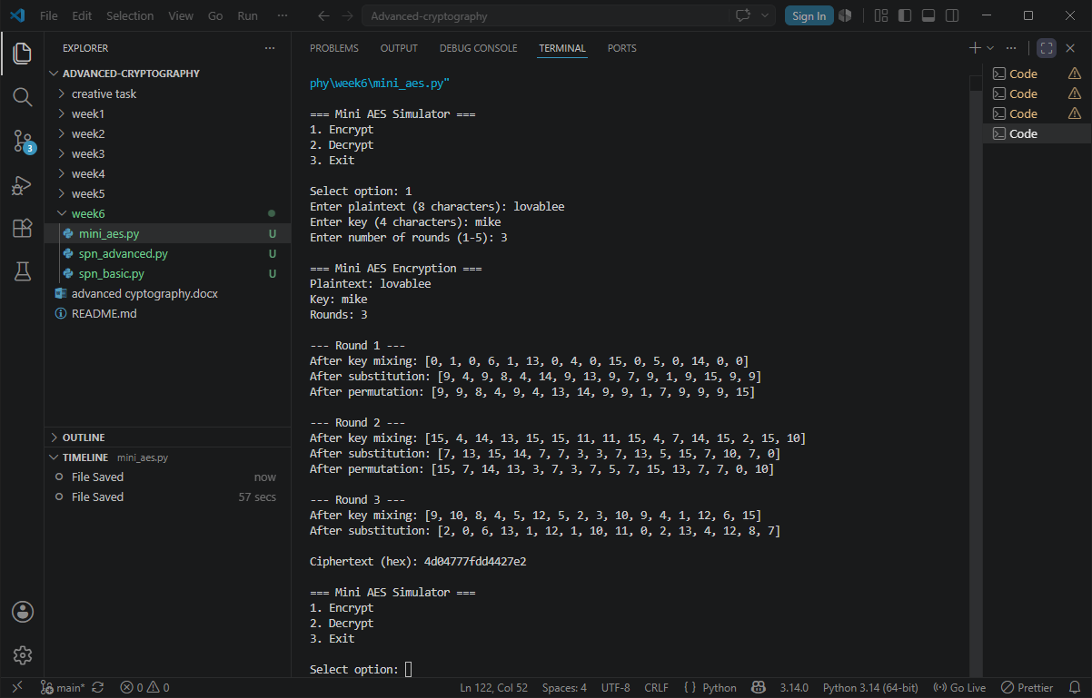

FIG 3: mini AES output

WEEK 7: BLOCK CIPHER CRYPTANALYSIS

Title: Differential cryptanalysis and Linear cryptanalysis
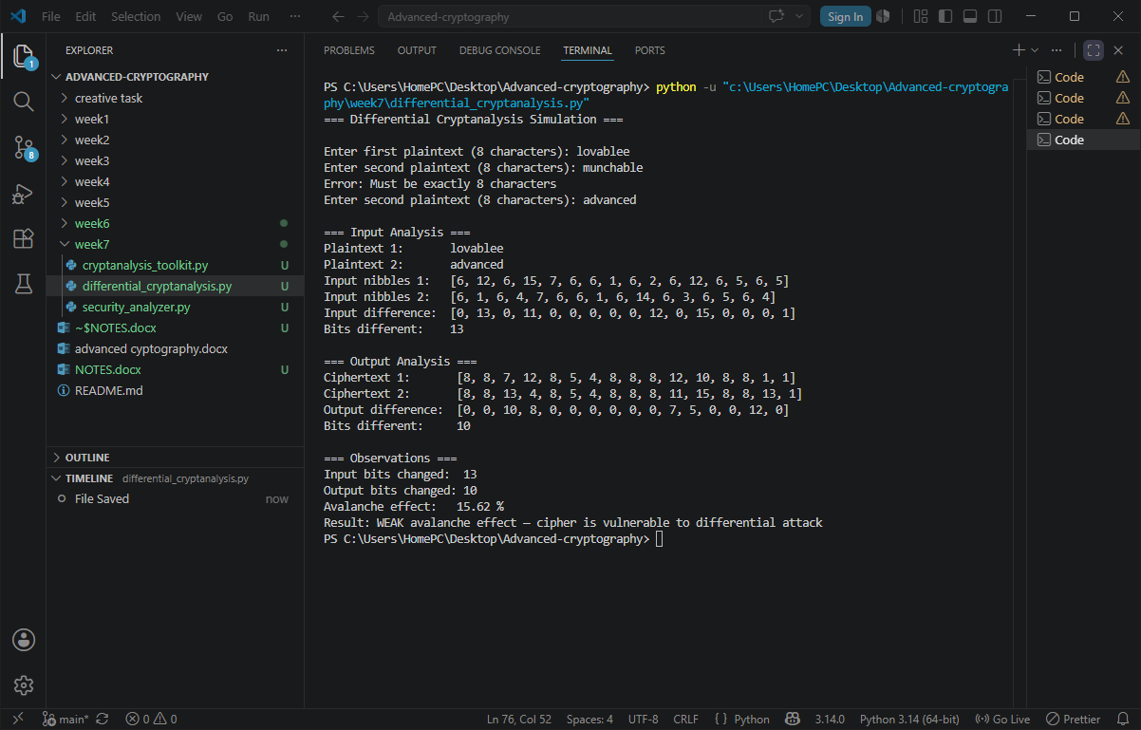

FIG 1: differential cryptanalysis output

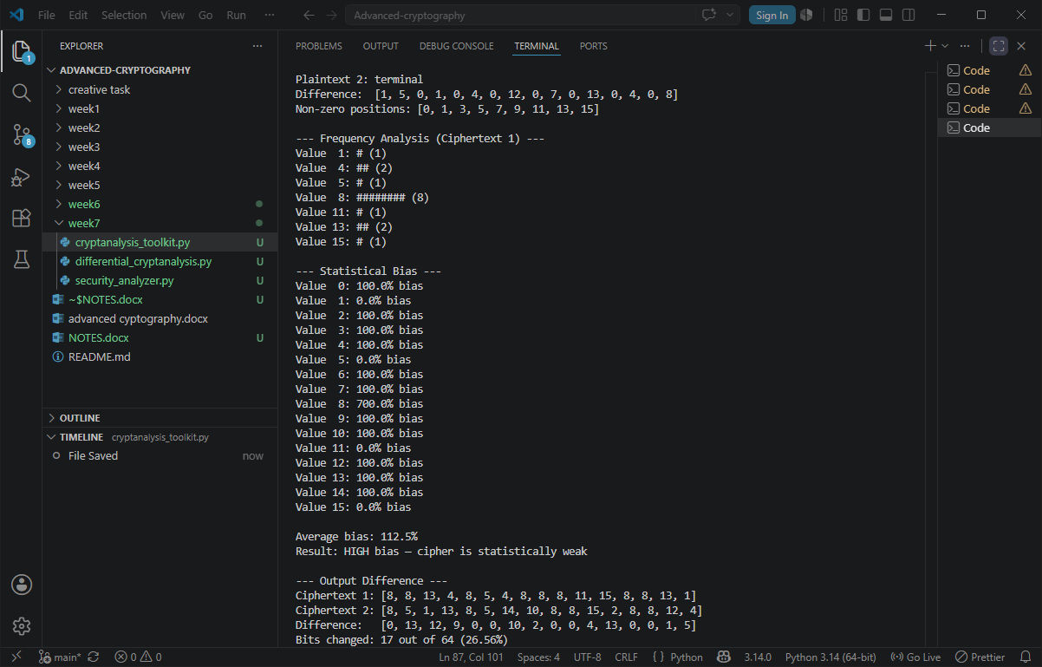

FIG 2: output showing frequency analysis, statistical bias and output difference
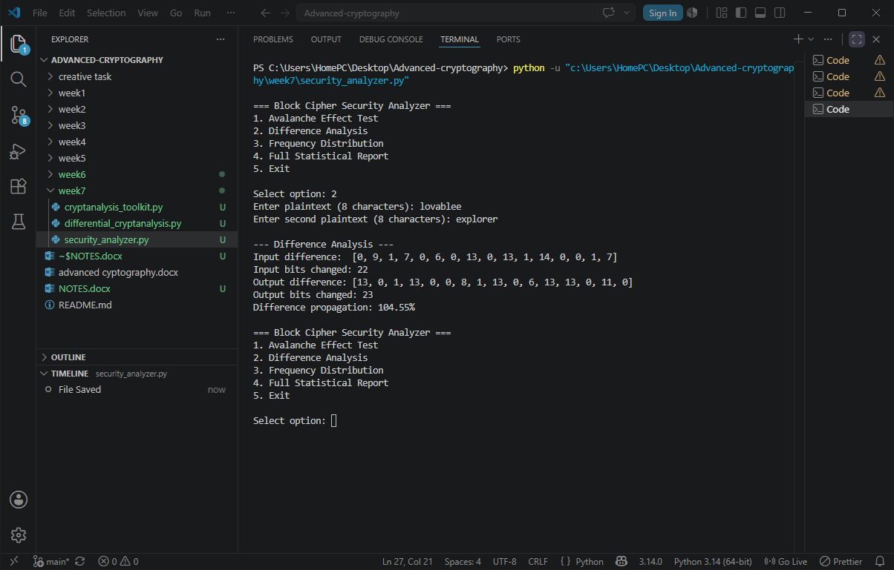

FIG 3: difference analysis output

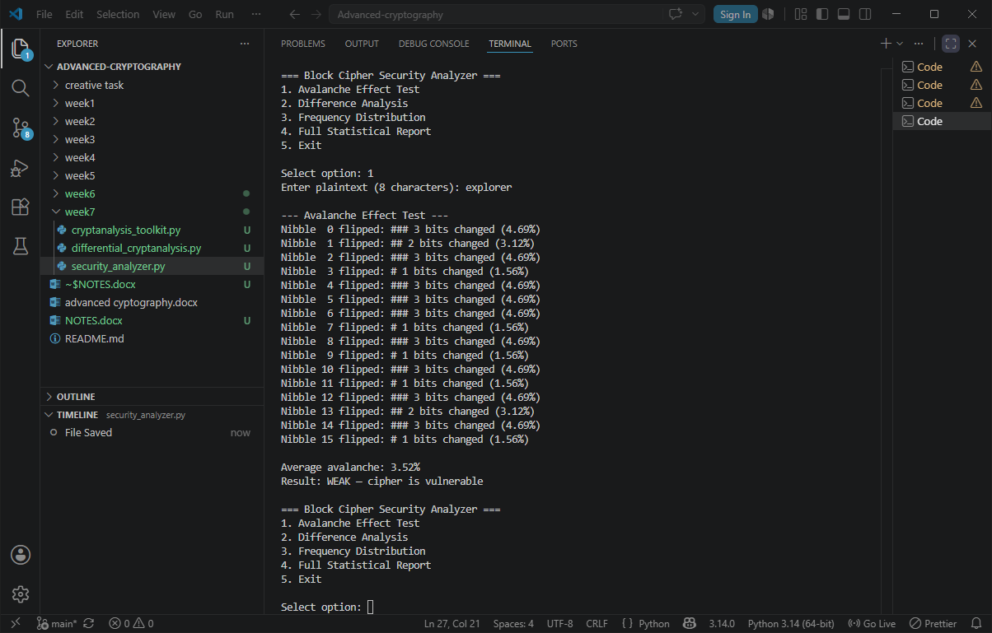

FIG 4: Avalanche test results output
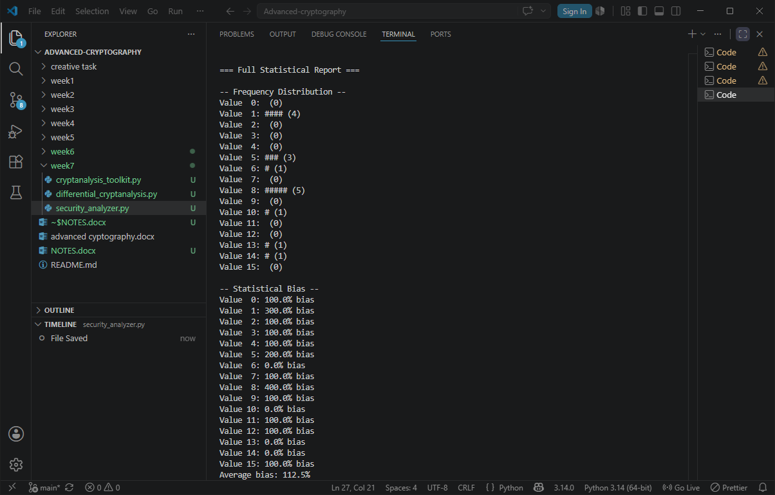

FIG 5: full statistical report output

STUDENTS REFLECTION
Learnt how differential cryptanalysis is used to study how small unput differences propagate through encryption to expose key patterns while linear cryptanalysis exploits mathematical bits between plaintext, ciphertext and key bits to recover the key.

WEEK 8: ASYMMETRIC CIPHERS, INTRACTABILITY, NP-COMPLETENESS, AND THE DIFFIE-HELLMAN CRYPTOSYSTEM

DIGITAL CERTIFICATE SECURITY INCIDENT
- Organization involved
DigiCert, Inc. (Global Certificate Authority)
- Cause of the incident
The breach was initiated through a targeted social engineering attack against DigiCert's customer support channel. The attacker made contact through the support team's chat portal and delivered a malicious ZIP archive disguised as a customer-submitted screenshot. in the archive was a .scr file which, when opened by a support analyst, installed malware on the endpoint.
- Impact on users
Secondary Defender incident
Reputational damage
Mass revocation disruption
Certificate abuse for malware distribution.
- Corrective actions taken
Endpoint protection audit
Portal feature review
Rapid revocation
Containment
- Lessons learned for PKI security
Endpoint Detection Must Be Universal and Verified
Certificate Transparency Enables Community Defense
CA Audit Perimeters Must Cover Support Infrastructure
Revocation Infrastructure Must Be Reliable and Fast

References
Markovic, S. (2026, May 4). DigiCert breached via malicious screensaver file. Help Net Security. https://www.helpnetsecurity.com/2026/05/04/digicert-breach-code-signing-certificates-malware/
Mozilla Foundation. (2026). Bug #2033170 — DigiCert incident report. Bugzilla. https://bugzilla.mozilla.org/show_bug.cgi?id=2033170
CA/Browser Forum. (2023). Baseline requirements for the issuance and management of publicly-trusted code signing certificates (v3.3). https://cabforum.org/

DIFFIE-HELLMAN KEY EXCHANGE
Diffie-Hellman- is a cryptography method used to let two people create a shared secret key over an insecure network without sending the secret itself.
How it works
The protocol works by allowing two devices to create the same secret key without transmitting the secret itself. Example
Imagine Phone A and Phone B want to create the same secret password for encryption,
Step 1: Public values
The phones first agree on:
Prime number (p) = 23 Generator (g) = 5
Step 2: Each phone chooses a private secret
Phone A -6, Phone B -15
Step 3: public value created by phones
Phone A: 5⁶ mod 23 = 8. Phone B: 5¹⁵ mod 23 = 19
Step 4: Exchange values
Phone A sends 8, Phone B sends 19
Step 5: same secret key creation
Phone A: 19⁶ mod 23 = 2. Phone B: 8¹⁵ mod 23 = 2
Both now have the same secret key as 2

DISCRETE LOGARITHM PROBLEM
Is the problem of determining the exponent power in a modular arithmetic equation when the base, prime number, and result are known.
It is considered computationally difficult for large numbers and forms the security foundation of cryptographic systems.

APPLICATIONS IN TLS/SSL
DH Modes in TLS
SSH: Secure remote access and system administration over untrusted networks.
IPsec / VPNs: Key generation and rotation for encrypted tunnels.
PGP: Encrypted email communication.
Signal Protocol: End-to-end encrypted messaging in applications such as WhatsApp and Signal

SECURITY CHALLENGES AND SOLUTIONS
Challenges
Man-in-the-Middle Attacks
Weak Parameters
The Quantum Computing Threat
Solutions
Mutual TLS extends this by requiring the client to present a certificate as well.
Use safe primes and unique, server-specific DH parameters rather than shared defaults.
Quantum Key Distribution (QKD

References
Diffie, W., & Hellman, M. E. (1976). New directions in cryptography. IEEE Transactions on Information Theory, 22(6), 644–654.
Comparitech. (2023, August 24). What is the Diffie–Hellman key exchange and how does it work? https://www.comparitech.com/blog/information-security/diffie-hellman-key-exchange/
DTI Techs. (2025). The Diffie-Hellman key exchange. Practical Foundations in Cybersecurity. https://dti-techs.gitbook.io/practical-foundations-in-cybersecurity
The Quantum Insider. (2026, April 6). How quantum computing affects cryptography. https://thequantuminsider.com/2026/04/06/how-quantum-computing-affects-cryptography/

